# **PERSONAS:**



**Name: Daniel**



**Age: 20**



**Location: Gainesville**



**Technical comfort: Advanced**



**Major: Informatics**



**Back story**

•Daniel is an out going student.

•He is part of college band.

•Frequently stays in campus.

•Loves compute and is geek at heart. He uses VPN to remain anonymous, uses macros on Excel and loves to learn programming languages during his free time.

**Motivations**

• He values time over money.

• Always has some events lined up on weekends.

• Often drives around trying to find a parking spot close to his events.

**Frustrations**

• Wastes time driving around to find the parking spot

• Decal coloring system very confusing

• Gets confused trying to find the right parking spot.

**Their Ideal Experience**

• Doesn’t have to waste time driving around to find parking spot.

• The application gives him details about all the nearest parking spots.

• **Only parking spots accessible for his decal are visible.**

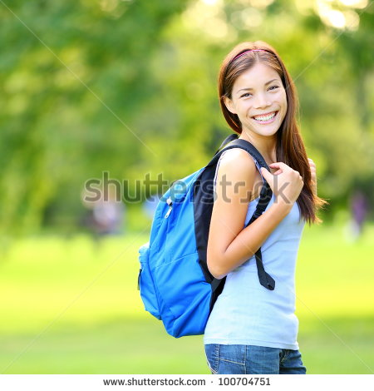

**Name: Sharon Collins**



**Age: 21**



**Location: Gainesville**



**Technical comfort: Intermediate**



**Major: Chemical Engineering**



**Back story**

•Sharon is a sophomore studying chemical engineering

•Likes to follow latest trends and fashions

•Recently landed internship at Dow Chemicals and treated herself a Toyota Corolla

•Has an android and likes to believe she is pretty good at operating it. Installs most of the new trending applications and uses it.

**Motivations**

• Thermodynamics class is quite a few miles from nearest parking lot.

• She often parks her car and then catches a bus which stops near chemistry building.

• Would like to find parking spots near bus stops.

**Frustrations**

• Has to walk quite a few miles from her parking lot to destination.

• Wastes lot of time to find bus stops after parking her car

• Sometimes forgets exactly where her car is parked in the parking lot. Would like to keep track of it.

**Their ideal experience**

• Doesn’t have to waste time driving around to find parking spot.

• **The application gives her details about all the parking spots near bus stops.**

• Application has a feature to keep track of where exactly car is parked.

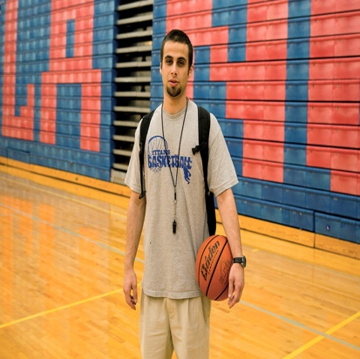

**Name: Chris**



**Age: 19**



**Location: Gainesville**



**Technical comfort: Beginner**



**Major: Animal Science**



**Back story**

•Loves sports

•Part of UF basketball team and holds record form most points in single game.

•Suffered a knee injury

•Loves Cars and recently bought a Toyota pickup truck

**Motivations**

• Wants to find spacious parking space.

• Due to his recent injury will love to reserve a disabled spot for few days.

• Wants to find parking space near his destination.

**Frustrations**

• Doesn’t have much expertise in using apps. Would prefer checking basketball game scores on TV than using some app

• Wants spacious parking spot as recently had minor incident where his truck was damaged when another car s trying to back

out in parking lot.

• Despite being in clutches, has to some times walk a few miles if nearby parking spot is not available.

•Very few disabled spots don’t help the matter either.

**Their ideal experience**

• **Help him find available disabled spots.**

• The application is user friendly and doesn’t require much technical expertise.

• App has a feature which gives him details about parking lot which are spacious.

• App has a feature to view and post reviews about particular parking lot.